Chakradhar Bhogapurapu, BIBA

Types of SQL commands

There are 4 types of SQL commands. They are DDL, DML, DCL and TCL.

* DDL: DDL stands for Data Definition Language that is used to manage data and its structure. DDL have commands like Create, Alter, Drop, Truncate, Rename.
* DML: DML stands for Data Manipulation Language that is used to manipulate data. DML have commands like Insert, Update, Delete.
* DCL: DCL stands for Data Control Language that is used to command access and security.
* TCL: TCL stands for Transaction Control Language that is has the commands like Commit, Rollback, SavePoint.

ACID properties:

* Atomicity: It checks if all the operations have completed successfully. If not, then the transactions will be ended.
* Consistency: Data will be in consistency state before and after the transactions.
* Isolation: One transaction will not interfere in another transaction and operates independently.
* Durability: The result will not be lost in case of system failure.

To run any SQL command, we need to create a database to store the tables.

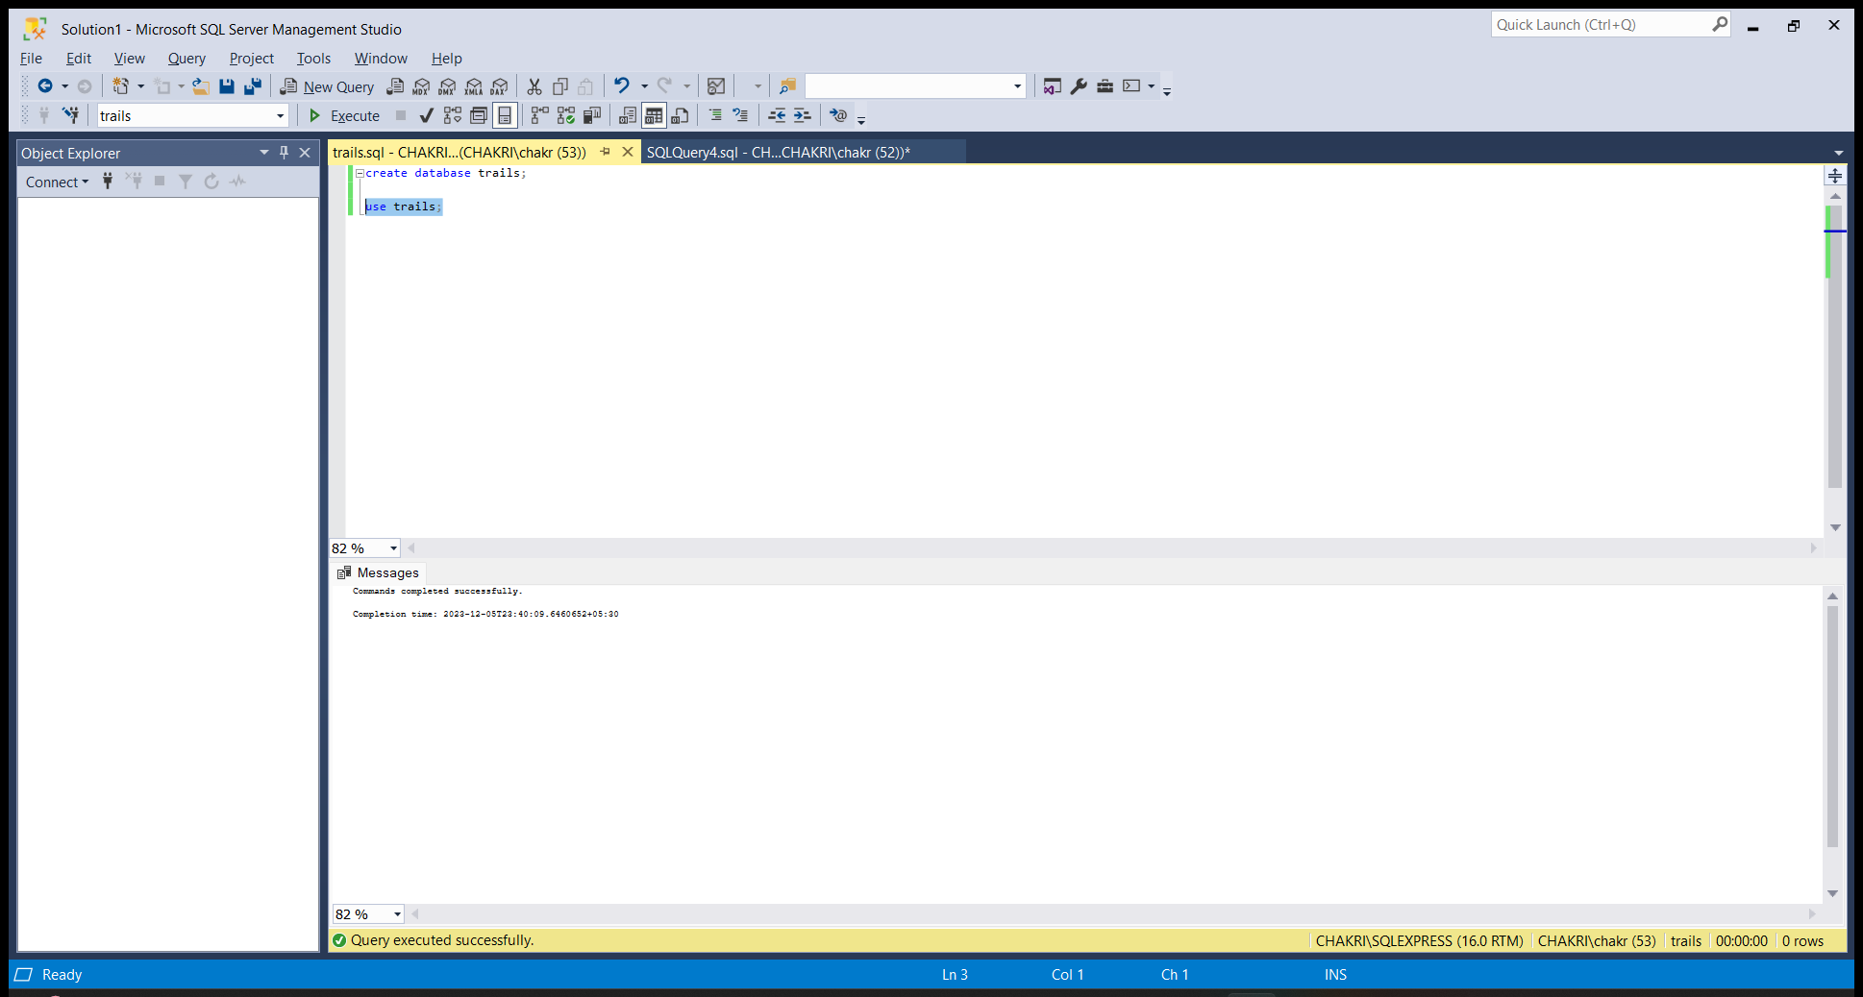

The syntax for creating database is ‘CREATE DATABASE DATABASE_NAME’.

Now the database is create. Now we have to use it. To use it, the command syntax is, ‘USE DATABASE_NAME’.

CREATE:

Create command is used to create a table with a specified table name. We need to specify the column name and the type of the column. The syntax for creating a table in database is,

CREATE TABLE TABLE_NAME (COLUMN_NAME1 DATA TYPE, COLUMN_NAME2 DATA TYPE,…);

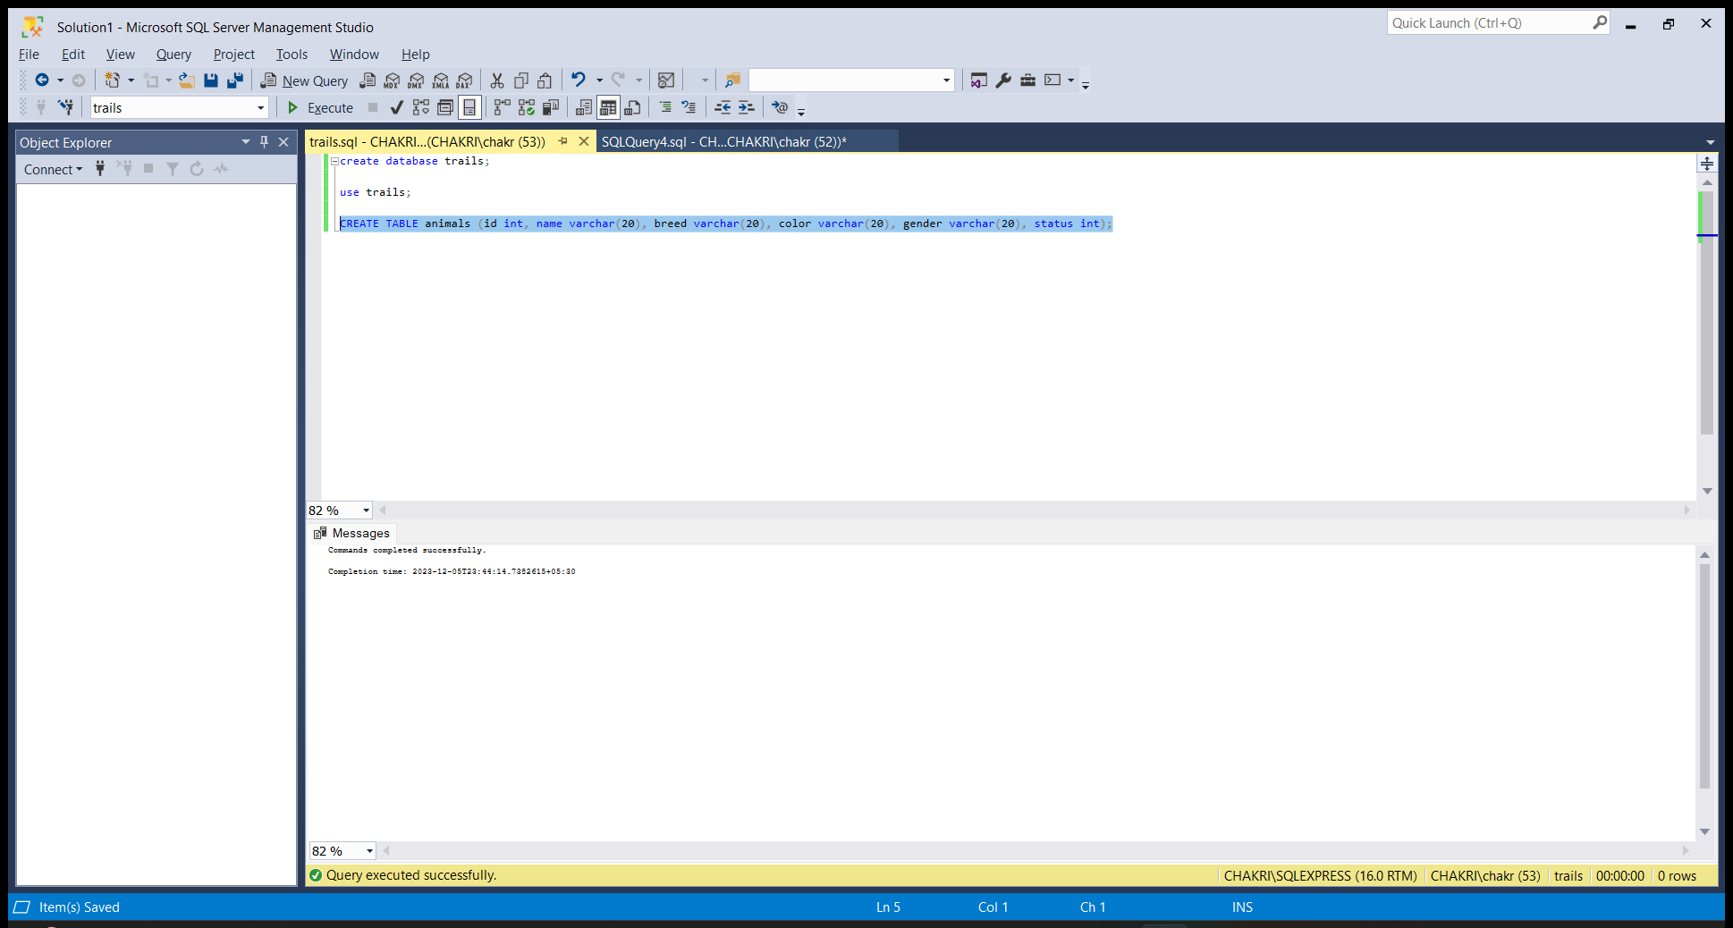

INSERT:

This command is used to insert values into the table.

The syntax for inserting is :  
 INSERT INTO TABLE_NAME(COLUMN_NAMES)VALUES(VALUES);

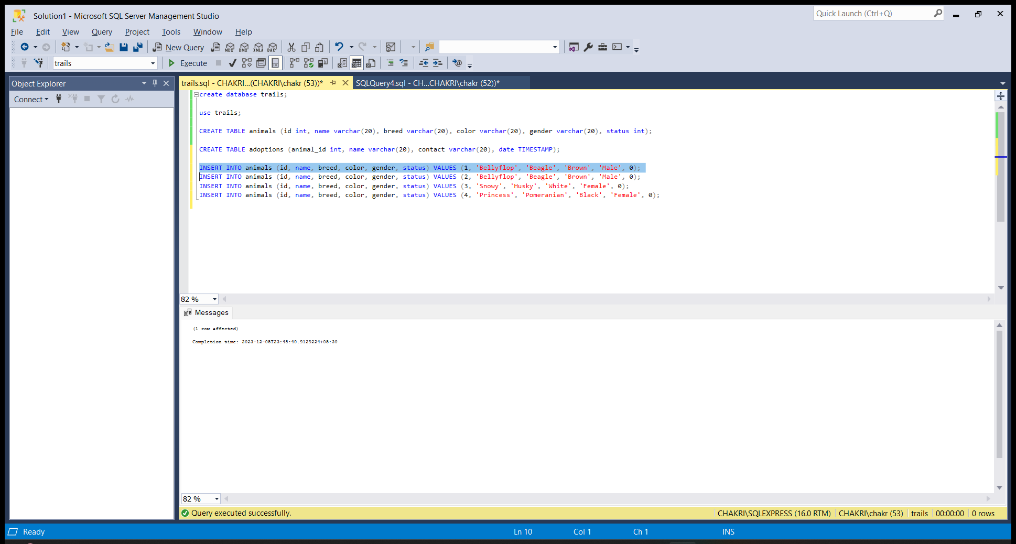

SELECT:

Select command is used to display the table data.

The syntax for select command is,

SELECT * FROM TABLE_NAME;

Here * represents to select all the data from the table. 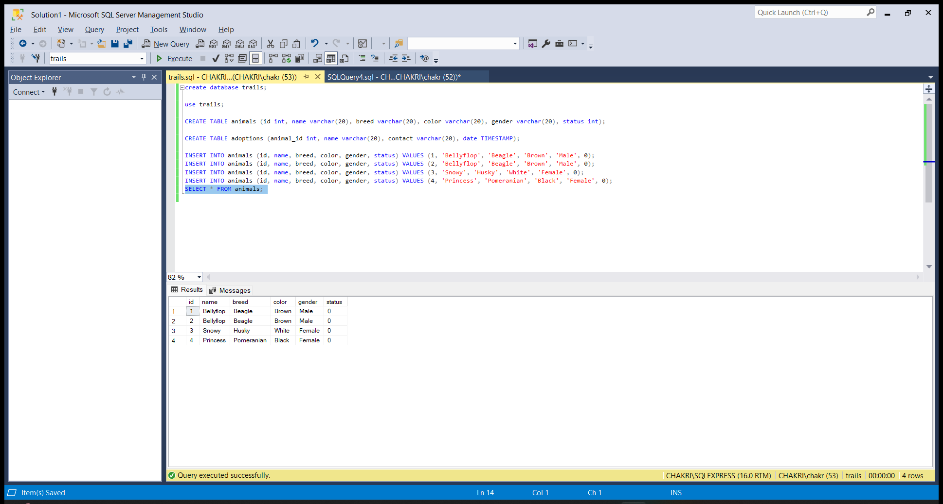

WHERE:  
Where clause is used in SELECT command to obey the given condition.

Here all the data is not selected from the table. Only the data that has met the condition will be displayed as an output.

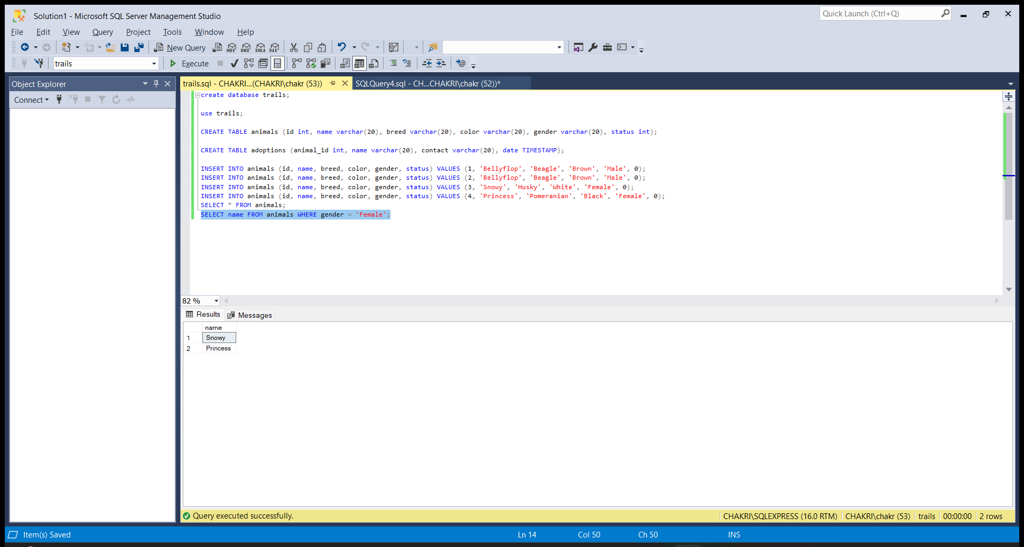

UPDATE:

Update is a command that is used to edit the already existing record in a table. The Syntax for UPDATE is:

UPDATE TABLE_NAME SET COLUMN_NAME=VALUE WHERE CONDITION;

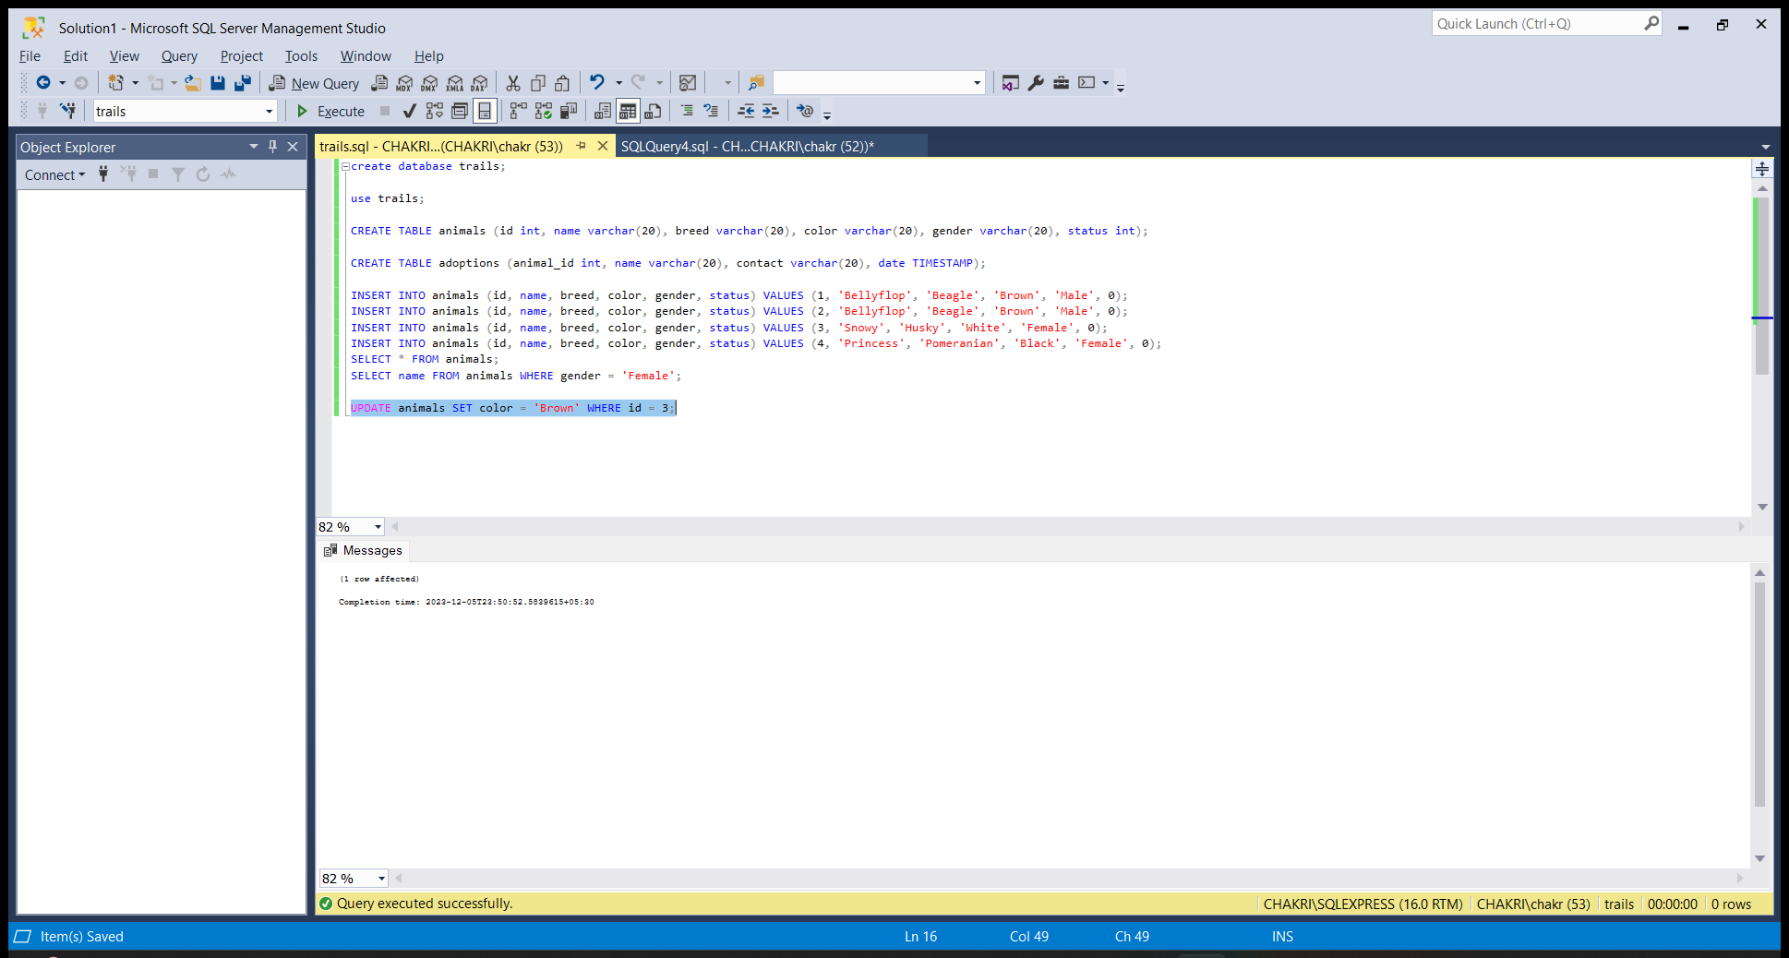

ALTER:

Alter is an sql command that is used to add a new column to the existing table.

The syntax for ALTER is:

ALTER TABLE TABLE_NAME ADD COLUMN_NAME DATA TYPE;

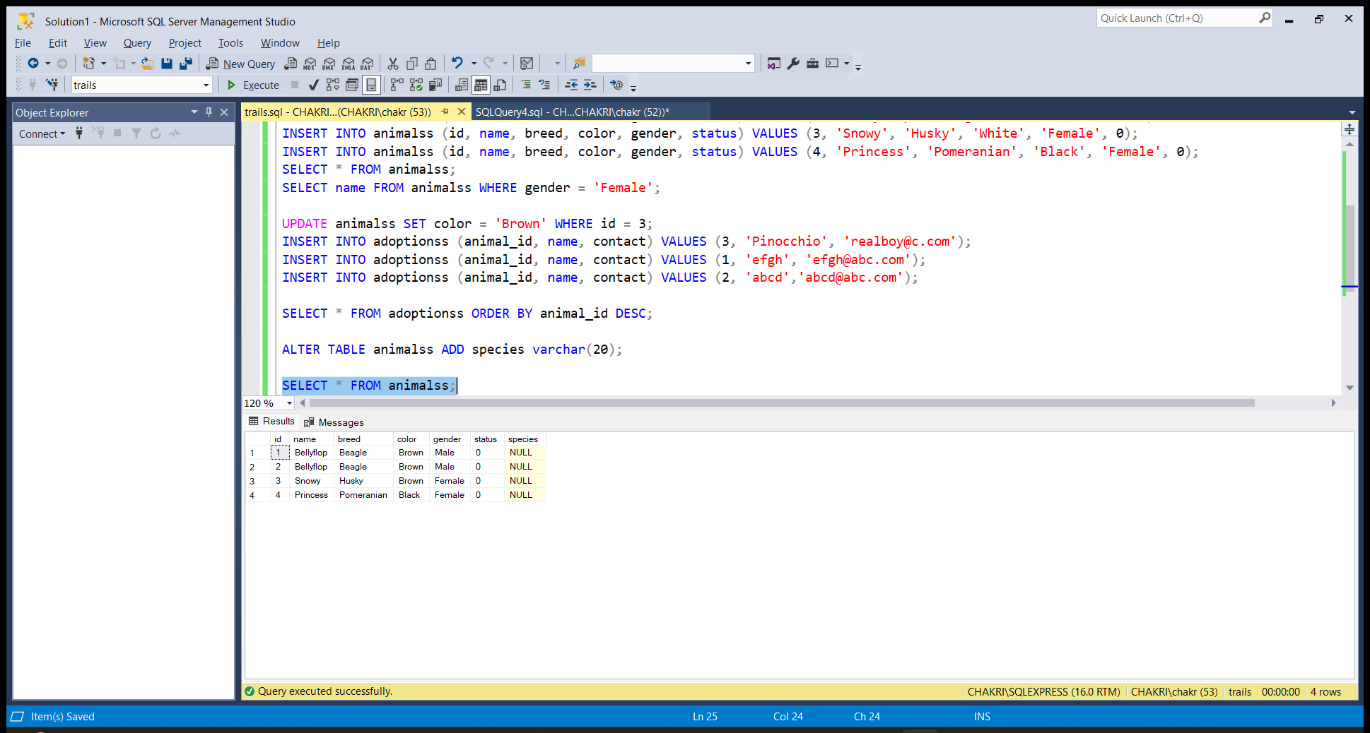

ORDER BY:

ORDER BY is a command that is used to keep the rows in an order. Either Ascending or Descending order. The syntax for ORDER BY is:

SELECT * FROM TABLE_NAME ORDER BY COLUMN_NAME DESC/ASC;

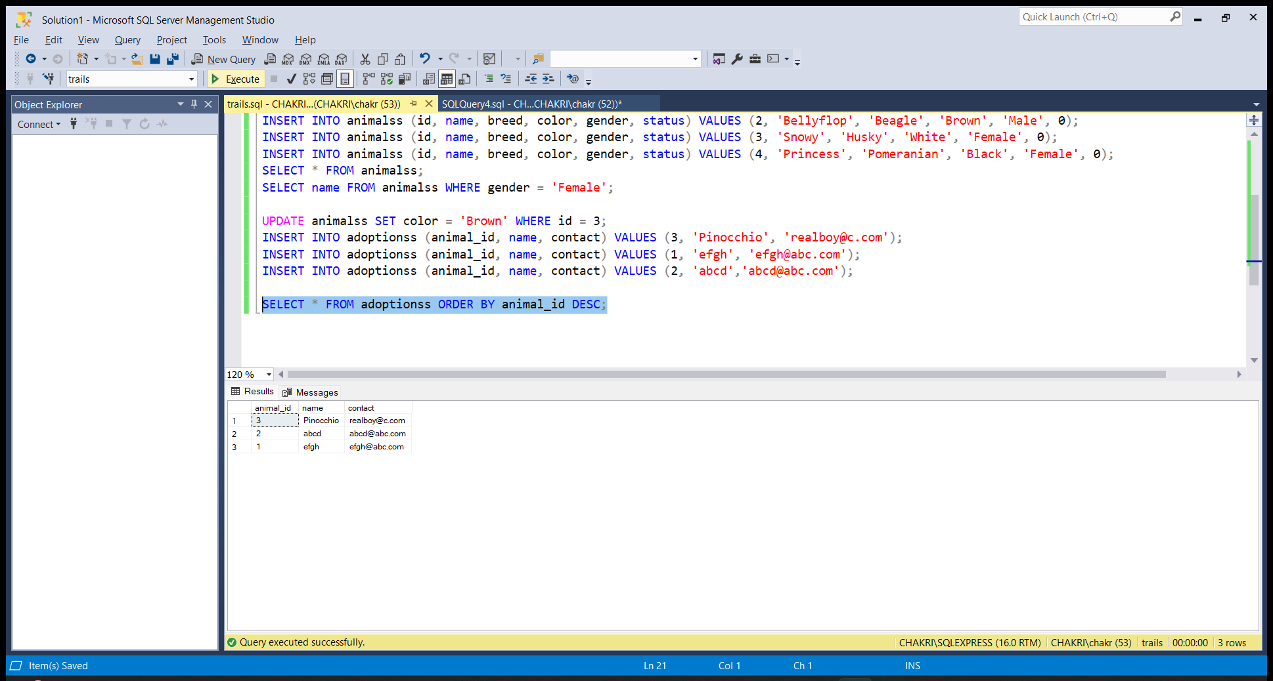

DELETE :

Delete is an sql command that is used to delete specific row based on the given condition. The syntax for DELETE is:

DELETE FROM TABLE_NAME WHERE CONDITION;

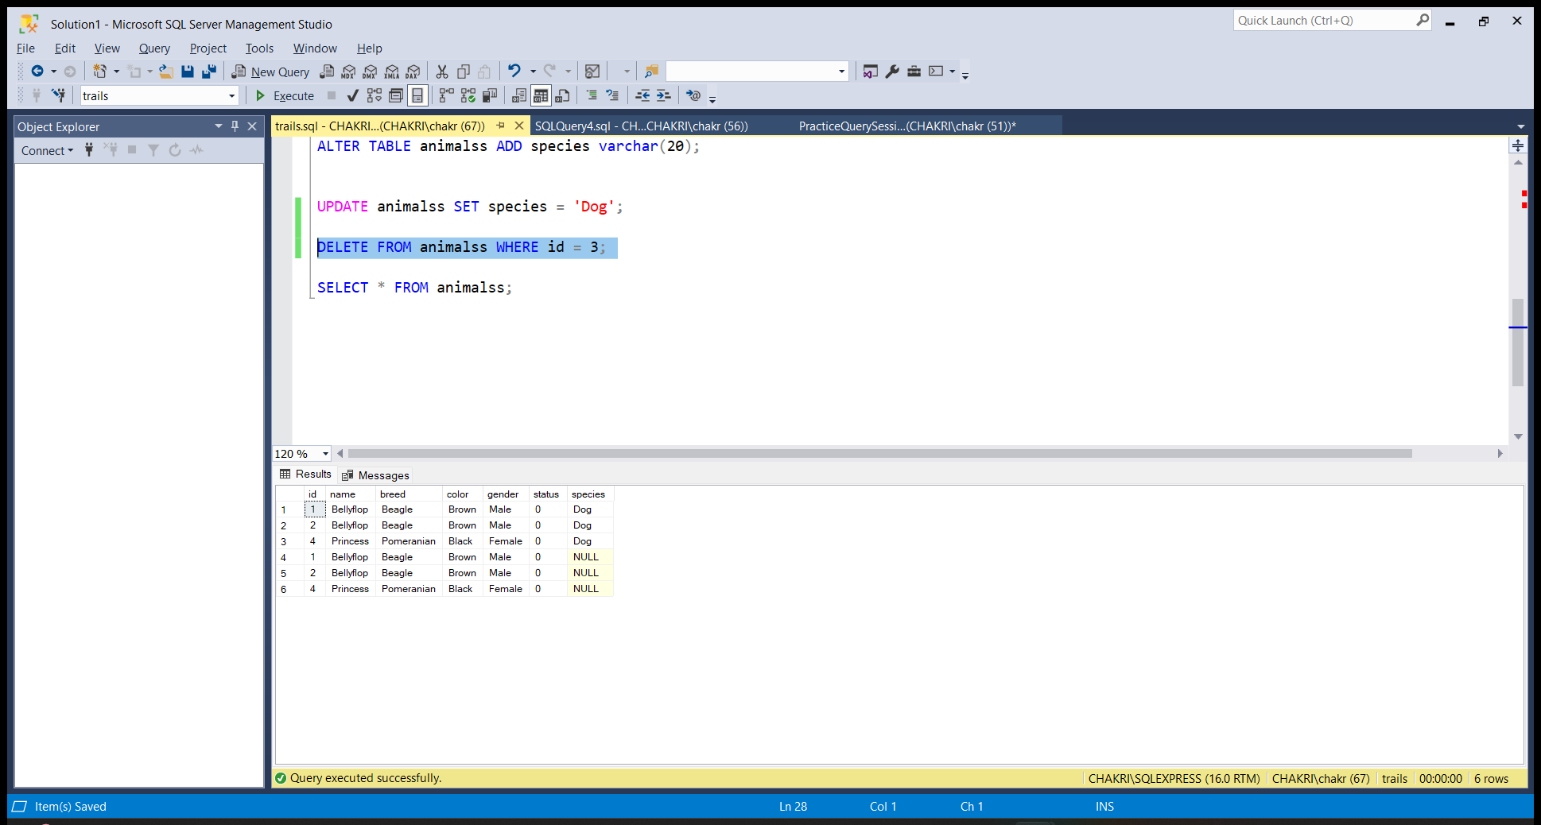

DROP: Drop is used to delete the entire table from the database.

Syntax: DROP TABLE TABLE_NAME;

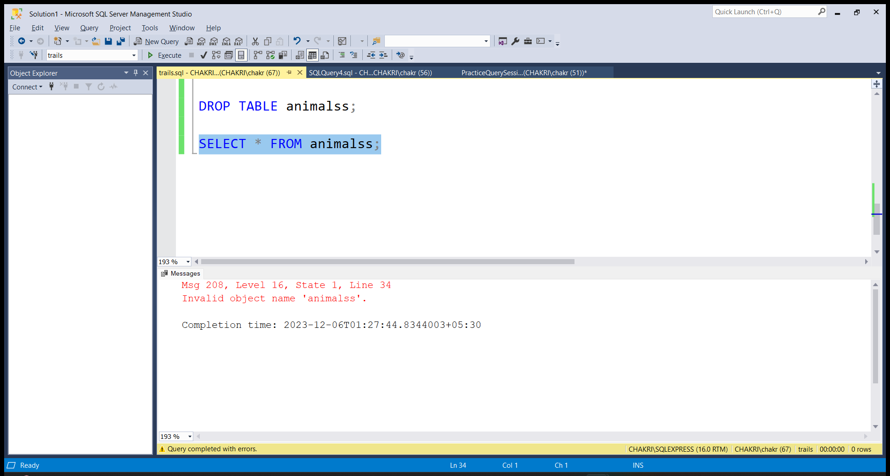

TRUNCATE:

Truncate is an SQL command that is used to delete the table data but not the table itself.

The syntax for TRUNCATE IS:

TRUNCATE TABLE TABLE_NAME;

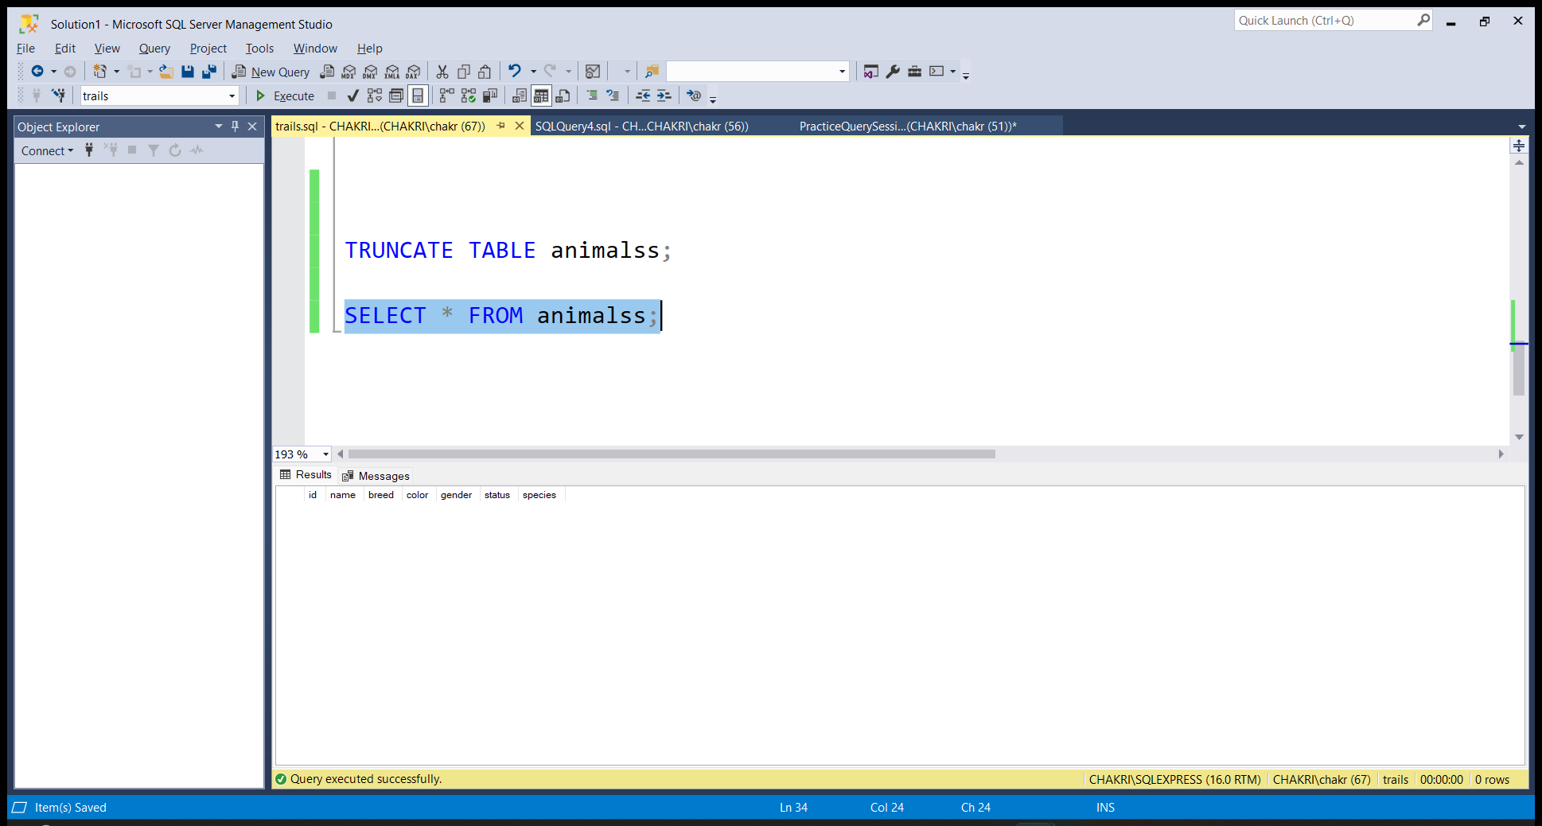

PRACTICE QUERIES: 